Newsletter
Issue 11

24 November 2023

Dear Parents and Carers

Parish Council Project
The school councillors had a very exciting trip today to
Oliver’s Battery Park.
Constance Leach from the Parish Council was there to talk to the children about the tree planting project that has been happening in our local park.
The school councillors helped the Parish Council to plant some trees.
It was lovely to be part of such an important local project and
great to see the children getting involved.
The Parish Council would like to invite people from the local area to help with watering the newly planted trees.
If you are interested please get in touch with Constance on
cllr.leach@oliversbatteryinfo
or
contanceleach154@gmail.com
A huge thank you to our school councillors for your interest and
enthusiasm. You are all a credit to our school.

Year 2
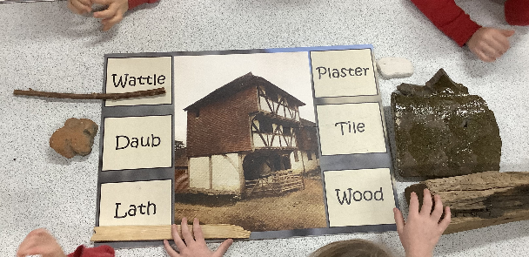
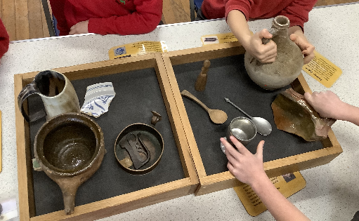
On Wednesday Year 2 had a very exciting history workshop in which they learnt all about the Great Fire of London. They enjoyed handling different artefacts and they showed so much curiosity about life back in 1666 – the visiting teacher was very impressed by the questioning and reasoning skills demonstrated by all. It was lovely to see how engaged and enthusiastic they all were!

Christmas Hampers
The PTA are organising the Christmas Hampers again this year. The colours for each class are:

Nursery Blue
Squirrels Silver
Ladybirds Red
Bumble bees Pink
Hares Green
Foxes Purple
Herons White
Kingfishers Gold

Please bring your hamper donation to the class teacher. Tickets will be sale shortly. Thank you for your support. The draw will be taking place in the last week of term.

Steve Brine’s Christmas Card Competition
Well done to all the children who took part in the Steve Brine Christmas Card competition. Everyone did really well – we didn’t have any outright winners this year but three children were Finalists – Frankie W, Liam G and Joshua P – their artwork will be on display in the Library in Winchester for the next few weeks.

Christmas Sweater Day
Thursday 7 December (Christmas Lunch day) will also be Christmas sweater day when we invite all the children, and staff, to wear a Christmas top for the day. There is no charge for this – it is just for fun!

Photographer Visit
A reminder that the school photographer will be back in school on Monday 27 November to take photos of anyone who was absent last week.

The deadline for ordering the school photos will be midnight on Thursday 30 November.

Ukelele Concert
Our Year Two and Year Four children will be performing for their families on Thursday 7 December (a separate email has been sent out) – Year Two at 2.00pm and Year Four at 2.30pm.

Menu Change
There will be a change to the Green Option for Monday 27 November – the green option will be: Tomato pasta – not meat free hot dog.

Poppy Appeal
Thank you to everyone who purchased goods on behalf of the Poppy Appeal – our school raised £178.19 – the snap bands went down very well!

Christmas Dates
Some dates for your diary –

Thursday 7 December - Christmas Lunch and Christmas Jumper day
Monday 11 December - Rock Steady Concert – 2.30pm
Tuesday 12 December – 2pm Nursery and Year R Nativity
Wednesday 13 December - Christmas Carols – 3.00pm (KS1 and KS2)
Thursday 14 December - Whole school trip to Pantomime (not Nursery)
Friday 15 December - No Breakfast Club

Charity Christmas Cards
If you would like to support a charity of your choice when buying Christmas Cards this year, pop along to the Brookes Shopping Centre in town as they are selling them from a shop unit in there. Many different charities are represented.

Santa Fun Run
This year’s Santa Fun Run will take place on Sunday 3 December in Winchester. The event is run by Naomi House and Jacksplace Hospices to raise vital funds for their fantastic Hospices and is a great family fun-filled event. If you would like to take part, or find out more, please visit their website naomihouse.org.uk/winchestersantafunrun

Christmas Holiday Lunch Scheme
Winchester Basics Bank are running a holiday lunch scheme over the Christmas break. This is designed to replace the hot meal that children would receive at school during term time. The scheme will provide food for ten meals per child. For more information or to register please visit: https://winchesterbasicsbank.co.uk/get-help/ or email: holidaylunch@winchesterbasicsbank.co.uk or telephone 01962 864720.
Kings’ School Vacancy
Kings’ School are currently advertising for a school receptionist. This job might appeal to parents as the job works around school hours. The job is for 22.2 hours a week. For more information please visit their website.
Direct4logos
Direct4logos our School Uniform supplier will be closed on the following Saturdays in December for essential maintenance work to take place:

Saturday 2 December
Saturday 9 December
Saturday 16 December

They will close for Christmas on Thursday 21 December at 12pm and re-open on Tuesday 2 January at 9.30am.

Learning Behaviours
We have held this week’s Learning Behaviours assembly. This is where each teacher chooses a child/children that has demonstrated the chosen learning behaviour of the week. The teacher shares with everyone what the child has done and then we all celebrate their achievement. This term we are looking at curiosity. The children who were chosen this week were:

Year One Scarlett I
Year Two Jamie P
Year Three Henry T
Year Four Pearl M-G
Year Five Noah Z
Year Six Layla Mc

School Lunches
Thank you to everyone for settling their lunch accounts, however the lunch debts are still high - please could you ensure that your account is kept up to date. For your information the money owed per class is as follows:-

Hares £ 126.33
Foxes £ 32.15
Herons £ 112.95
Kingfishers £ 162.80
Nursery £ 134.40

From Monday 18 September your child will not be able to order a school lunch if the debt is above £10.00 – if the debt is over £10.00 they will need to bring in a packed lunch. Please can you arrange to clear your Lunch accounts as soon as possible.

If you would like an up to date statement of your child’s account please contact the Admin Team. If you have not yet registered to pay online via Scopay and would like a copy of your login details please email us and we will be happy to help. We would appreciate it if all accounts, including any outstanding Breakfast Club and After School Club accounts, could be settled as soon as possible. Please ensure that your After School Club Account is up to date as we employ extra staff for this club. If you would like an up to date statement please contact the school office.

Thank you for your continued support.

Yours faithfully

Mrs Bordoli
Interim Headteacher

Dates for your diary (new dates in red)

Photographer for absentees 27 November 2023
Open Morning (9.30am) 29 November 2023
Flu Vaccinations 5 December 2023
Ukelele Concert (Year Two and Year Four) 7 December 2023
Christmas Lunch 7 December 2023
Christmas Sweater Day 7 December 2023
Rocksteady Concert 11 December 2023
Nursery and Year R Nativity – 2pm 12 December 2023
Christmas Carols 13 December 2023
Whole School Trip to Cinderella 14 December 2023
No Breakfast Club 15 December 2023
School breaks up for Christmas 15 December 2023
School returns for Spring term 2 January 2024
Open Morning (9.30am) 5 January 2024
Year R school applications close 15 January 2024
Inset Day 19 February 2024
Inset Day 28 June 2024
Inset Day 1 July 2024

